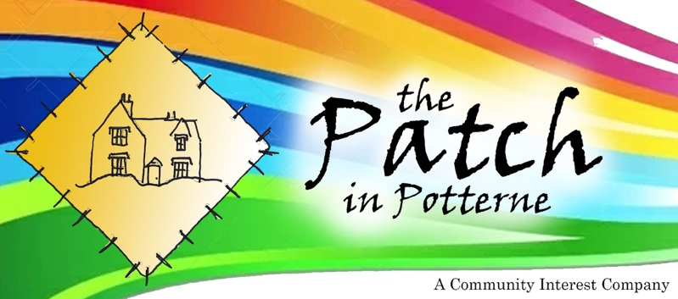
THE PATCH
IN POTTERNE
PROGRESS REPORT

www.thepatchinpotterne.org.uk

Registered Company No 14133290

Fundraising
Efforts continue to raise working capital for the purchase, subsequent refurbishment and initial running costs.

We had hoped to complete by the Autumn, following a substantial funding application made to the Community Ownership Fund (COF) however, we do not yet know the outcome as the fund was placed "on hold" after the July general election.

Enquiries as to the status of our COF application have elicited only a vague governmental response to an intervention by our new local MP, who enquired on our behalf. It would seem
that we have to wait at least until the 30 October Budget to find out more.
This is difficult news for our project as, if we don’t have adequate funding by early Nov 2024, then the owners of our potential community asset are likely to put the property onto the open market. If sold to developers, we would lose this wonderful asset and piece of village history as well as a very useful car park and cut-through route.

Having given this project our best shot, over the next 6 weeks we shall seek more donations, but fellow villagers need to be aware that time is short. We remain immensely grateful to everyone who has supported the project, including the Diocese who have so generously given us the additional time to fundraise and develop the project this far.

To find out more...
Visit our website thepatchinpotterne.org.uk and download our updated Business Plan.

Offers of help and / or enquiries are always welcome! Be it fundraising, admin, ideas for hiring space, please feel free to get in touch with us at any time.

Directors:
Bob Berry
John Chandler
Andrew Huntley
Robin Jéquier
Paul Moss
info@thepatchinpotterne.org.uk

